Trendy Toys DataBase Management

Divya Kommineni

Your github URL

Current date

1)

The company I choose is Trendy toys stores Inc. The company is located in the Virginia. It sells all action figures (toys) of animals such as Elephant, lion, tiger etc. The company has nearly 100 employees and working in one locations with main headquarters at Virginia.. The company manufactures the toys and sells it to stores (Walmart, Target, Costco etc )across the states. The major goal of the company is to establish their ideas innovatively and thereby develop new innovative toys that brings more sales and reputation in the market.

2)

<https://www.larktoys.com>

This company manufactures and sells the toys. It has nearly 150 employees situated in KELLOGG, MN ( Minnesota). The company is a reputated one as it sells different types of toys for less prices.

3) The client server architecture setup is distributed across the networks that are connected with different sets of stores that sells the toys. It uses the 3-level architecture here as it manufactures, sells and delivery the toys to the customers. In order to have the explicit functionality of creating the database to the store, it is important to ensure there is continuous flow of network.

The 5 tier functions are : manufacturing of the toy, presentation to the client or application and then storing the data in the database. The performance, availability and scalability can be put together and then formulate this tier architecture.

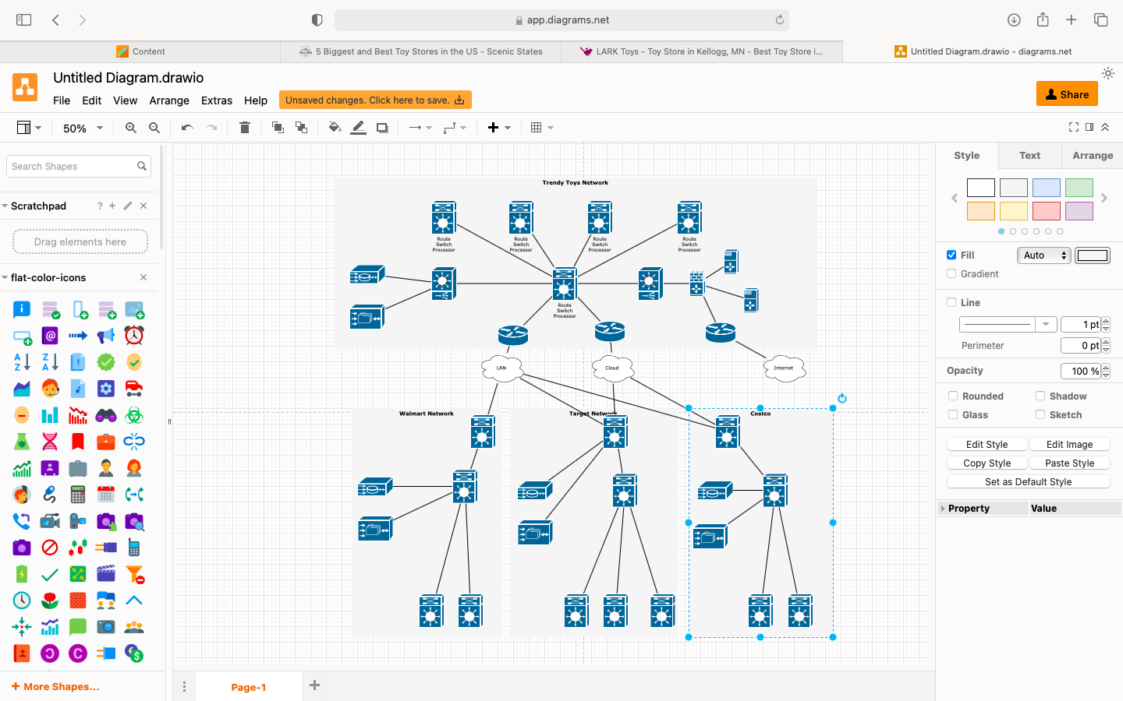

4)

In my database project the 5 important types of data are

Billing data

Sales data

Employee data

Customer personal information and credit information

Confidential data such as assets information.

In my view we have to update the data that is stored regularly and restrict access to the information. We must provide one time password authentication or some access control system that will allow the access only when the user is validated as per the security checks of the company.

5)

What kind of tool did we mention in class that performs data translations from one system to another?

Middle can perform the data translations from one system to another.

\* Name FIVE current examples of that tool, and provide the URL where you found the information.

database middleware, application server middleware, message-oriented middleware, web middleware, and transaction-processing monitors.

<https://azure.microsoft.com/en-in/resources/cloud-computing-dictionary/what-is-middleware/>

\* Name three common data formats that computer systems use to transfer product data between systems.

JSON,

XMl

CSV